Nude women in art: Are they really necessary?

An American university has come under fire for asking students to perform naked. And Picasso's painting of three nude women has just smashed auction records. Radhika Sanghani asks whether nudity is still a central part of art
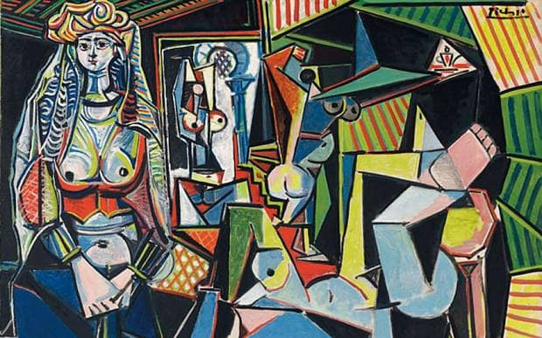
The cubist artwork shows a group of nude courtesans.
It’s not unusual to see naked women in art, of course. Indeed, the ratio seems to be so unbalanced that one group of women has set up an organization Guerilla Girls to expose sexism in the art world. Their goal is to stop objectification and divert the male gaze.
And no doubt the University of California might now be in their sights.
It has come under fire for asking students to perform naked in a candlelit room, as part of the final exam for an advanced visual arts class.
The project, entitled ‘The Erotic Self’, has been criticized after the mother of one of the students claimed her daughter was forced to perform nude, in a room where all the other students and male professor were also naked.
“It bothers me. I'm not sending her to school for this," she told KGTV in San Diego. "To blanket say you must be naked in order to pass my class - it makes me sick to my stomach."
The professor, Ricardo Dominguez, has been teaching the class for 11 years and said students knew what was expected from the beginning, explaining: “It's a standard canvas for performance art and body art. It is all very controlled. If they are uncomfortable with this gesture, they should not take the class.”
The university has explained the class is not mandatory and emphasized that students don’t actually have to remove their clothes. But it is taking the students’ concerns seriously.
Whatever the outcome, it raises questions around whether nudity in art is essential - and where the line falls between art and pornography.
- Why these naked women make me feel uncomfortable
Stephen Palmer, a life drawing teacher, tells me that nudity isn’t always sexual:
“People have the idea it’s quite titillating but actually it’s the opposite. If they were drawing them in skimpy underwear it might be different, but there’s something un-erotic about drawing nude figures.”
For him, the most important element is the context of the nudity – whether it’s the model getting naked or the art students themselves: “It’s the context of whether they feel humiliated or whether they’re happy to embrace that as the concept of the class. If they feel humiliated, I’d be uncomfortable with that.”
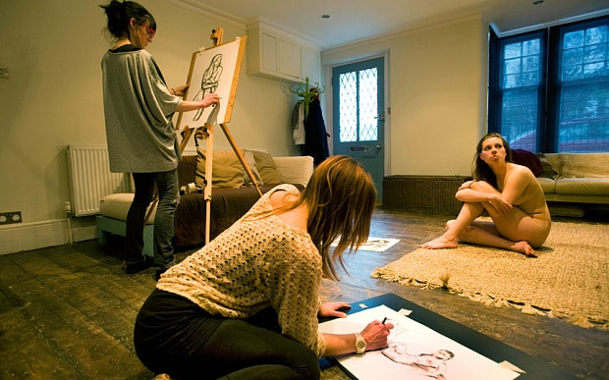Typically people prefer drawing female life models
He sees no difference between male and female nudity – though a number of life drawing teachers tell me that the most popular nude models are always female.
But not everyone feels the same way.
Roz Hardie, CEO of feminist organisation Object, tells me that it’s important to look at gender when it comes to nudity:
“In a British historical tradition, nudity is associated with not being powerful. It’s very common for women to be naked and men clothed. For women, unfortunately it’s often associated with over-sexualization, and there’s a focus on our body parts rather than who we are.”
She references the record-breaking Picasso painting as an example:
“It’s a picture of a harem. The most expensive picture in the world ever is an image of women being kept for the sexual availability of men. The idea that women exist for the sexual service of more powerful men I wouldn’t say is wrong for Picasso to paint, but it’s quite telling how women are often portrayed in some art in a very sexualized way.
“Today we’d probably consider [the courtesans in the painting] to be trafficked women and we’d be campaigning for resources to help them.”
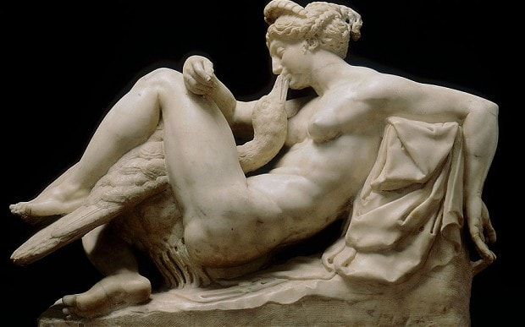Nudity in art: A 16th Century version of Leda and the Swan (Rex)
Like Palmer, she stresses the context is important and that nudity ib itself is not a problem – it’s just the message that the artwork is giving out.
This is something that Laura Dodsworth has direct experience of. She photographed 100 women’s breasts for her project ‘Bare Reality’, which aims to explore what breasts mean to women, and how they’re sexualized in the media.
“There was nothing provocative about it,” she says. “Breasts themselves aren’t inherently sexual. Just because in our culture they’re seen as sexual, they’re no more sexual than a man’s broad shoulders.”
She explains that nudity is all about “context and intent”, and though her project wasn’t meant to be sexually provocative, there’s nothing wrong with erotic art:
“I don’t think there’s anything wrong with art being sexually appealing. Can art be sexual and is that OK? Everybody would draw the line in a different place between art and pornography, but being sexual in art isn’t a bad thing.”
But Dodsworth agrees with Roz Hardie that even though creating erotic, nude art is not an issue in itself, it’s important to think about whether it suggests sexuality, or objectification.
Consent plays a huge part – especially in the case of the art students in California:
“Compulsory nudity as part of a course is really strange. That’s forcing someone to perform and express themselves according to someone else’s rules. That’s not art for me. There’s a difference between making people undress and there’s a difference between sexuality and objectification.”
This difference is integral in looking at whether nudity is gratuitous or necessary in art. There's no 'right answer' when it comes to asking people to strip off - the only thing that really matters is that they've consented to it, and feel comfortable with what they're doing.
It's the intention behind the nudity the matters, and in 2015, there's no need to see it as compulsory to produce good art.
As Palmer says: "This whole tradition of being in the nude? That’s no longer central to art.”

